..

**BT 3040: Bioinformatics**

**Assignment 12**



Indian Institute of Technology Madras

Atharva Mandar Phatak | BE21B009

Department of Biotechnology

## **Q1**) **Get the PDB files, 1ALC, 4LYZ and 1TIM**

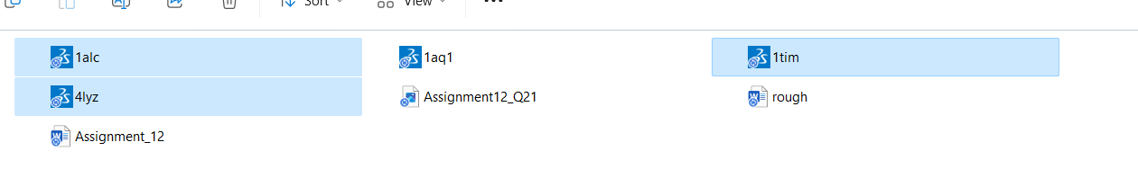

## **Q2**) **Open the file 1TIM and show in cartoon style (hide line style)**

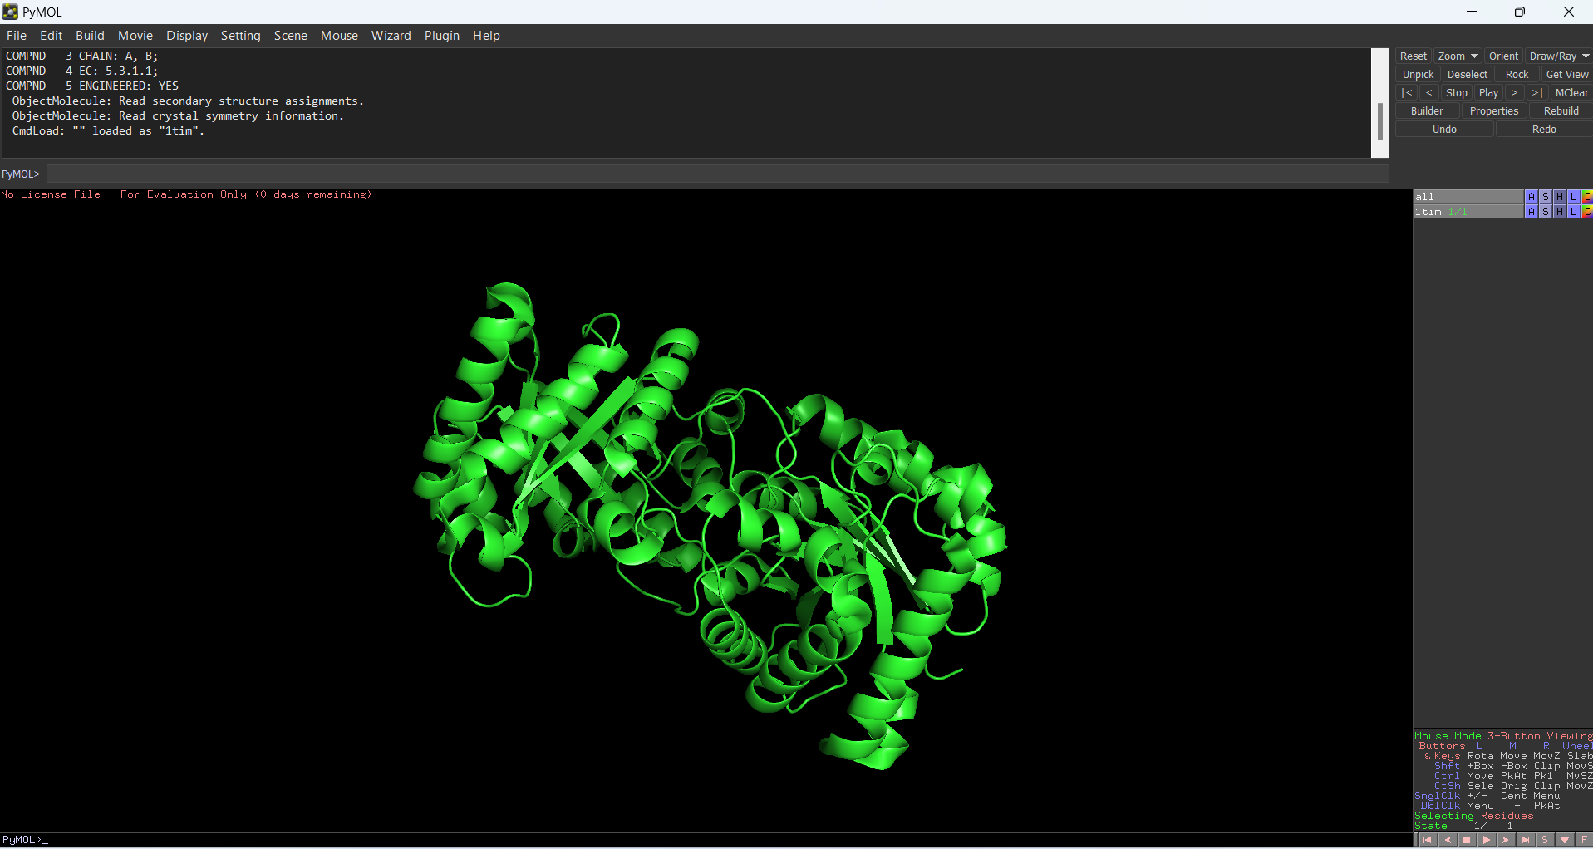

## **Q3) Give different colours for different chains. How many chains are there?**

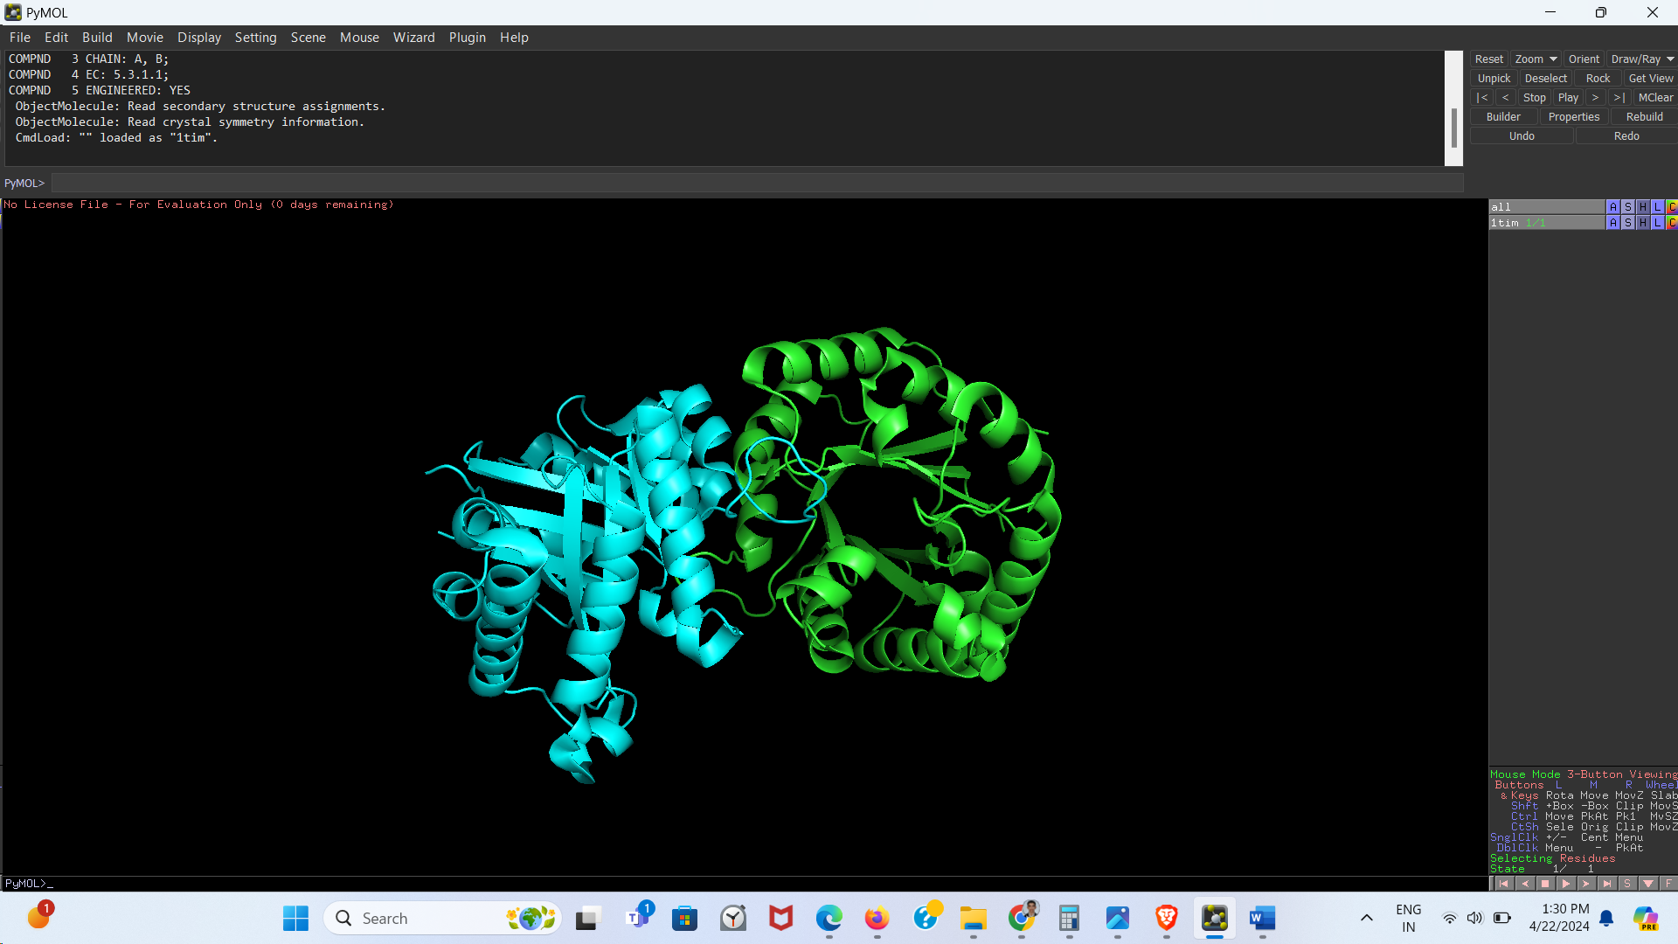

There are **two** chains

## **Q4) Remove one chain (right click on the chain and hide)**

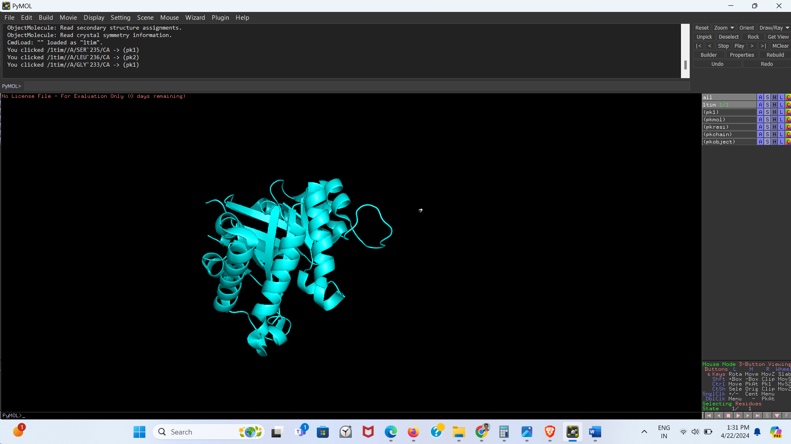

*Green Coloured Chain Hidden*

## **Q5) Identify the secondary structures with different colours**

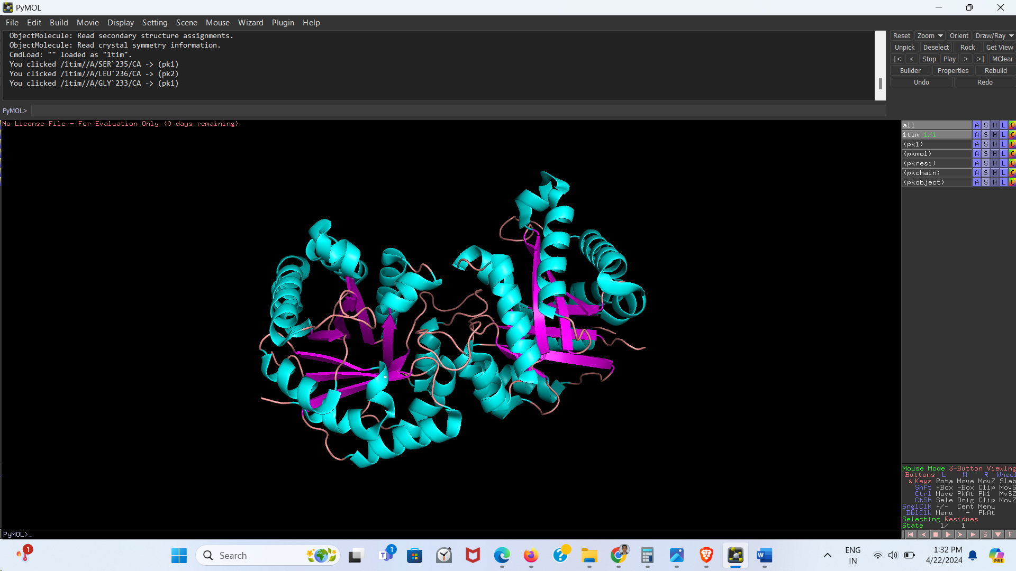

Helix have been represented by Light-Blue, Sheets by Pink and Loops by Orange

## **Q6) Zoom and rotate to get complete views**

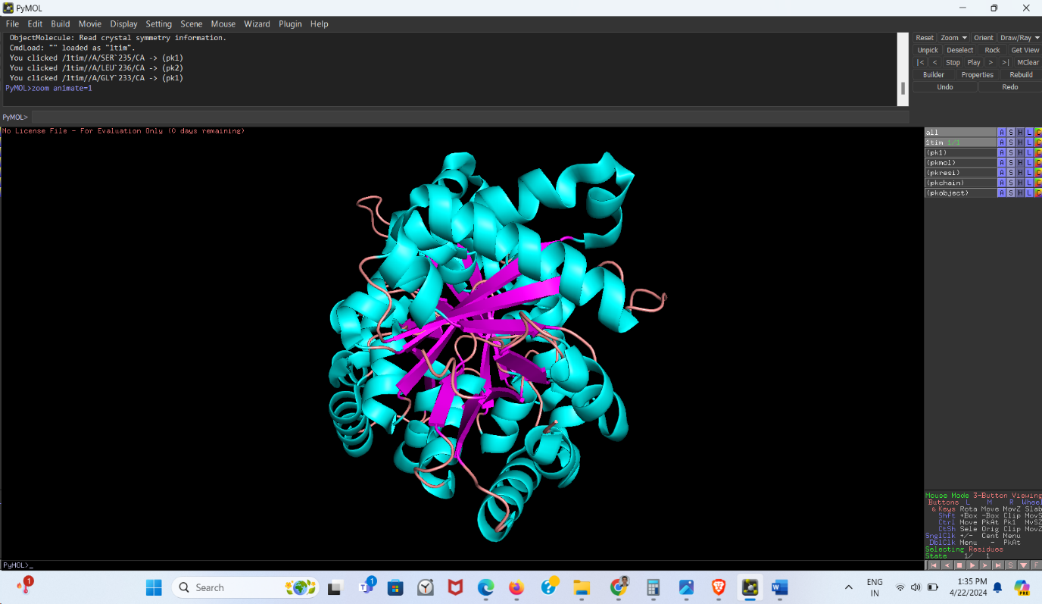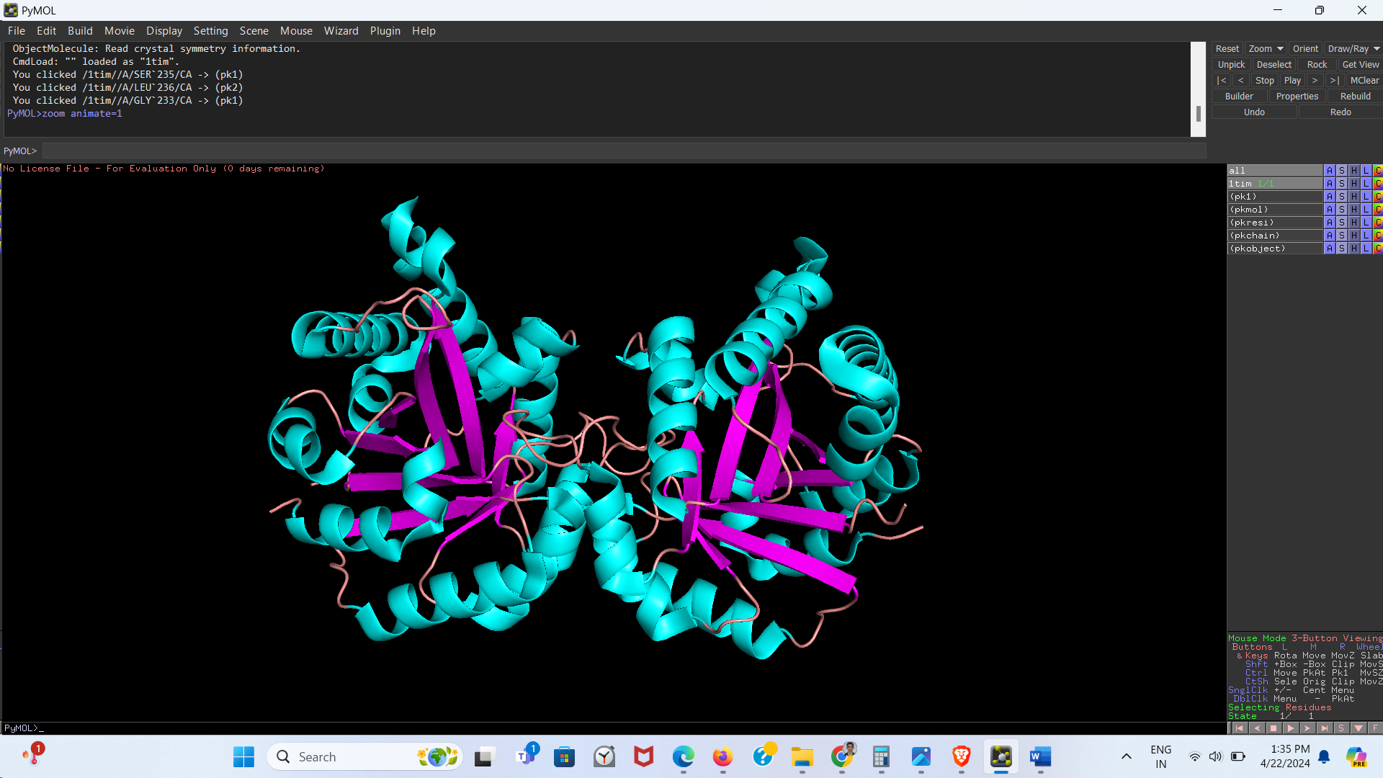

## **Q7) Show the sequence**

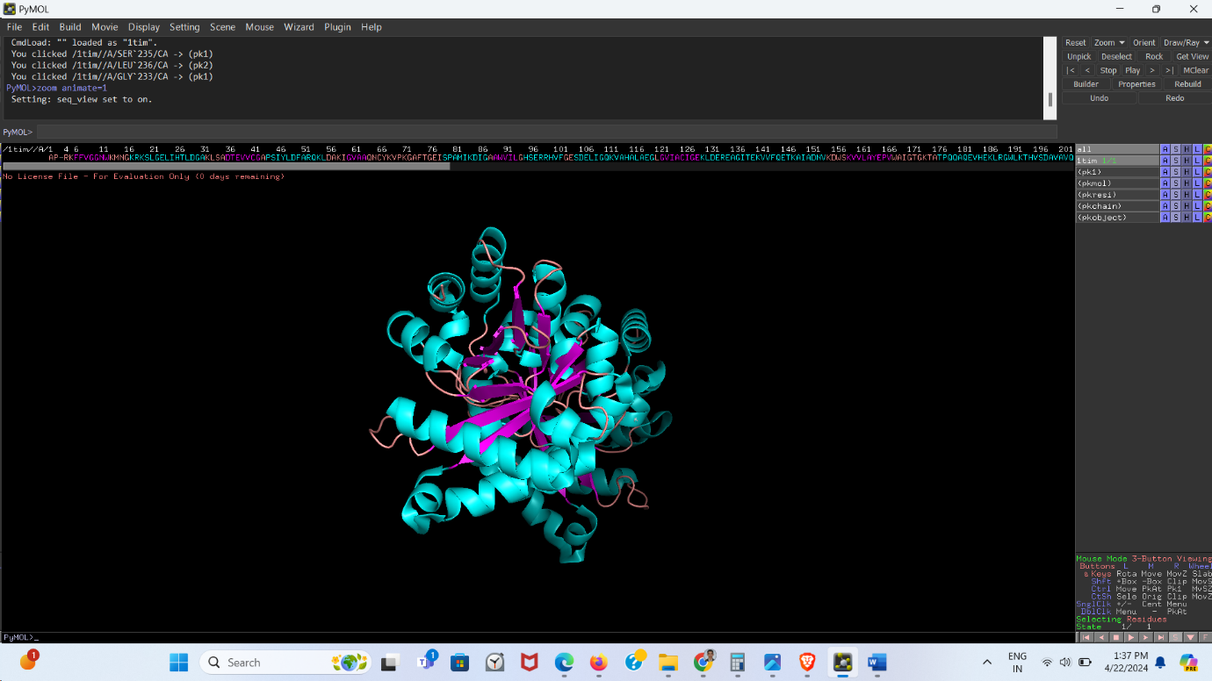

## **Q8) Select the residues 21 to 26: LGELIH**

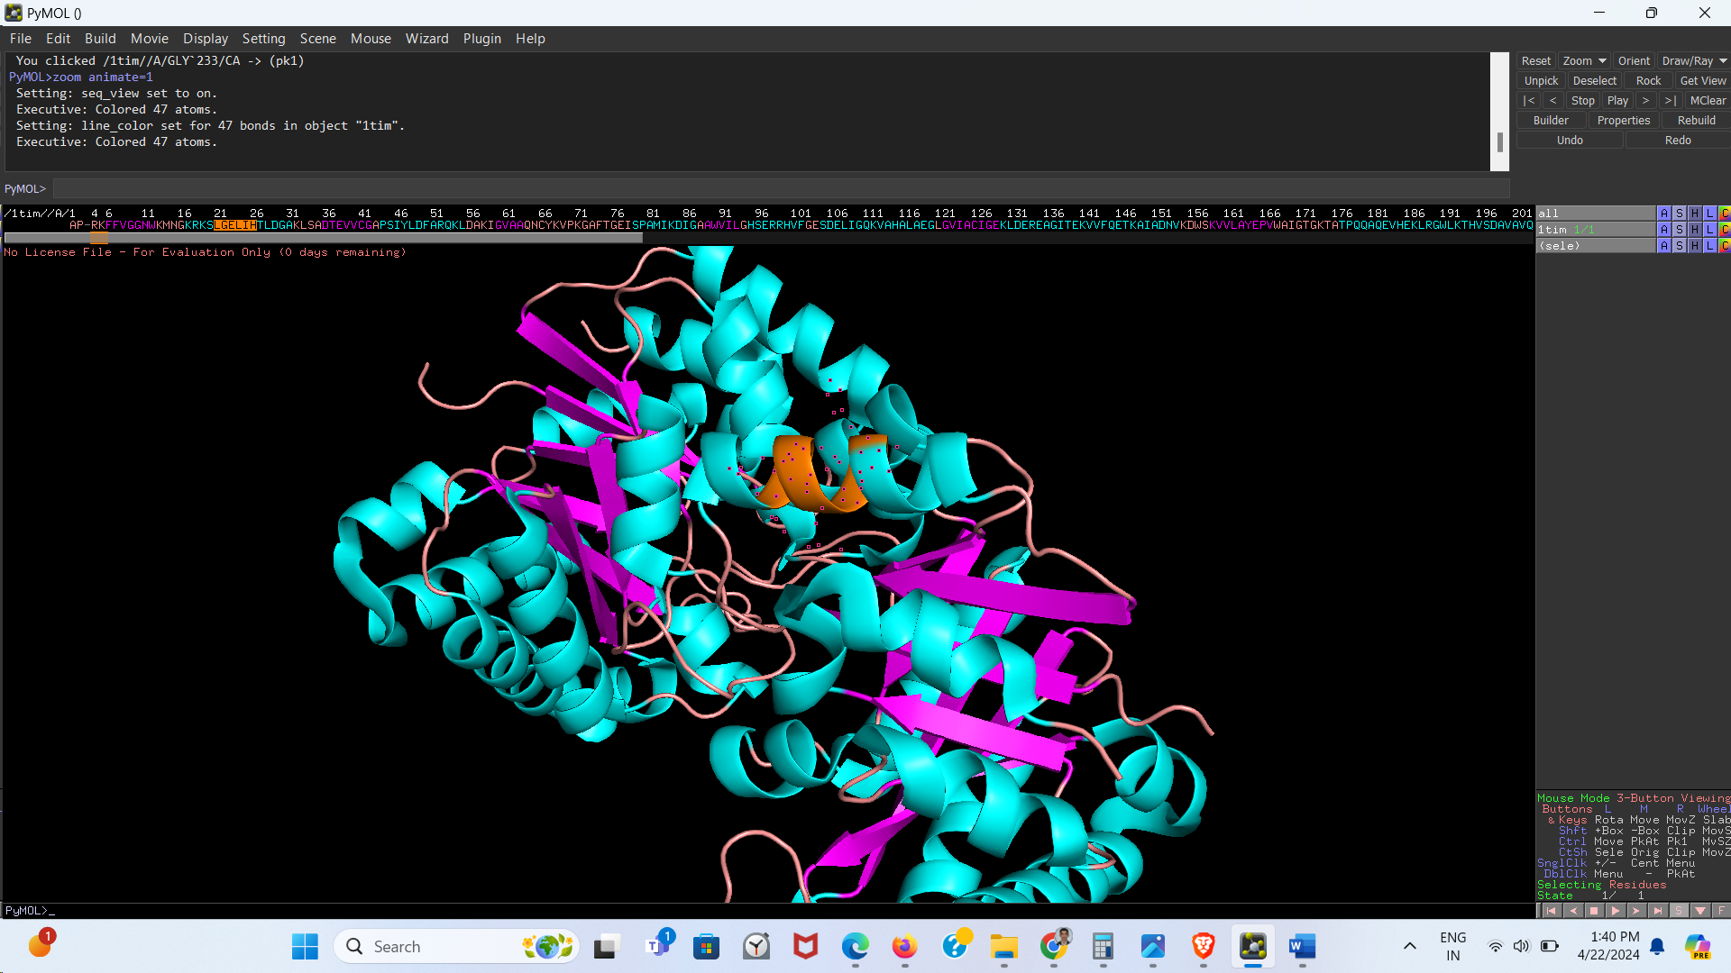

## **Q9) Hide cartoon diagrams**

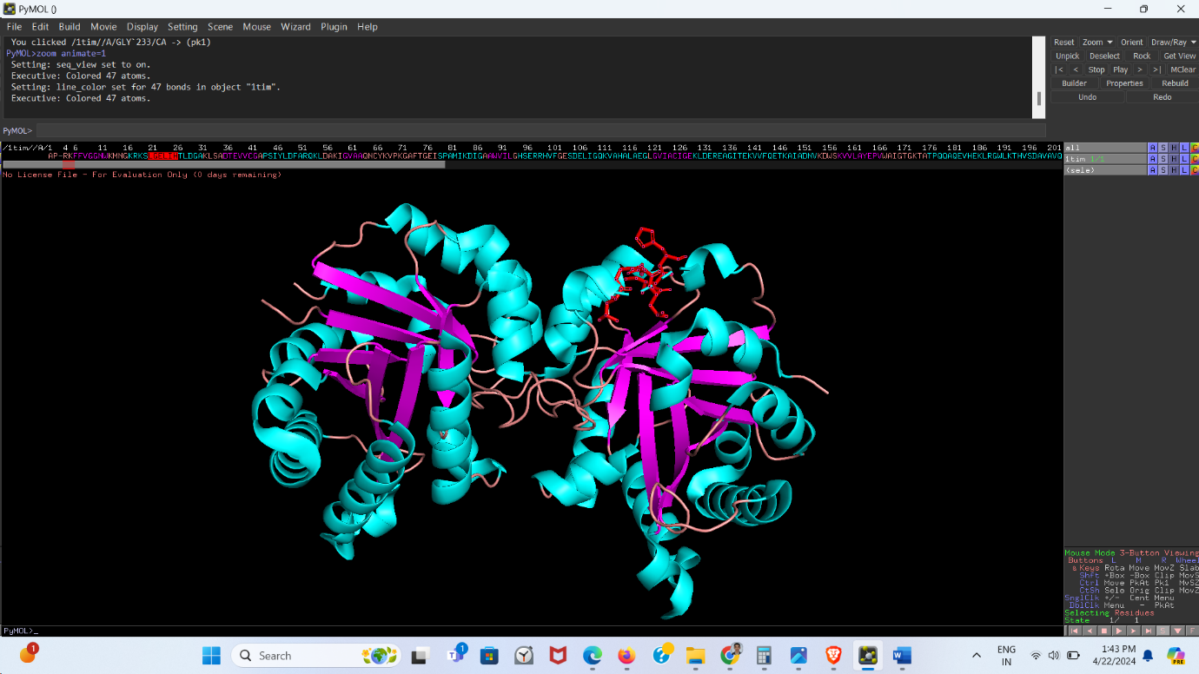

## **Q10)** **Colour the selected residues based on different atoms**

## 

## **Q11) Identify at least one salt bridge within the protein and list the details of interaction.**

## 

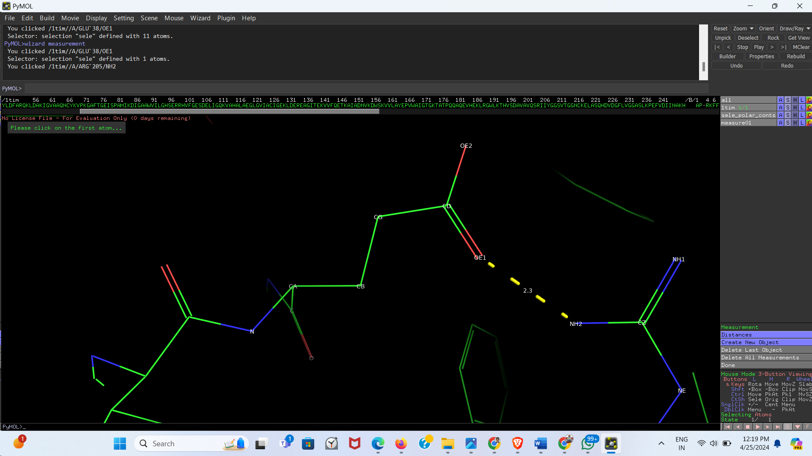

**Description:** Th interaction is seen between Glutamic Acid (E) at position 36 and Argnine (R) at position 205. The C=O group of Glutamic Acid forms a salt bridge with NH2 group of Arginine. The salt bridge is 2.3 A long.

## **Q12) Identify any hydrophobic interaction / aromatic stacking interaction protein and list the details of interaction.**

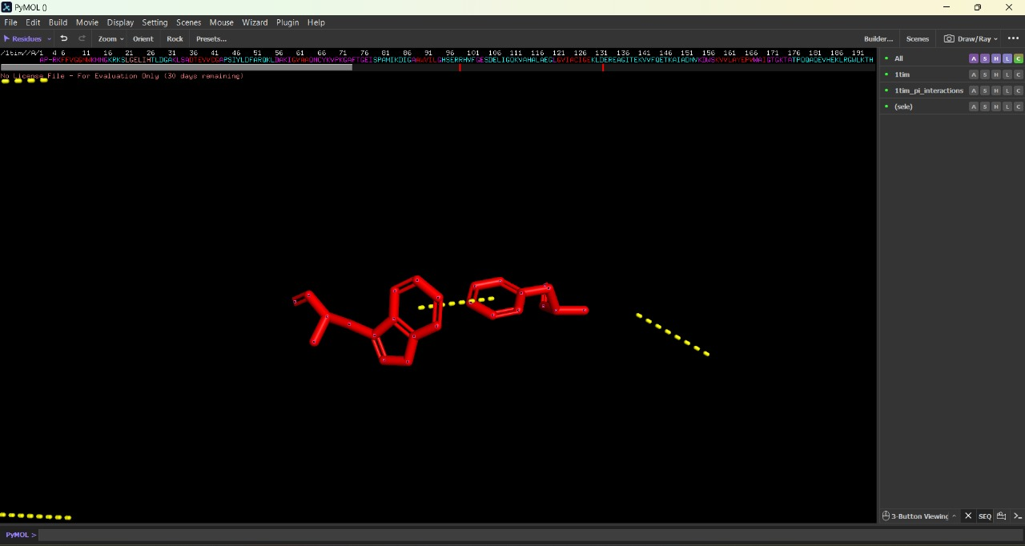

## **Q13) Label the residues using the atom name and show their van der Waal radii.**

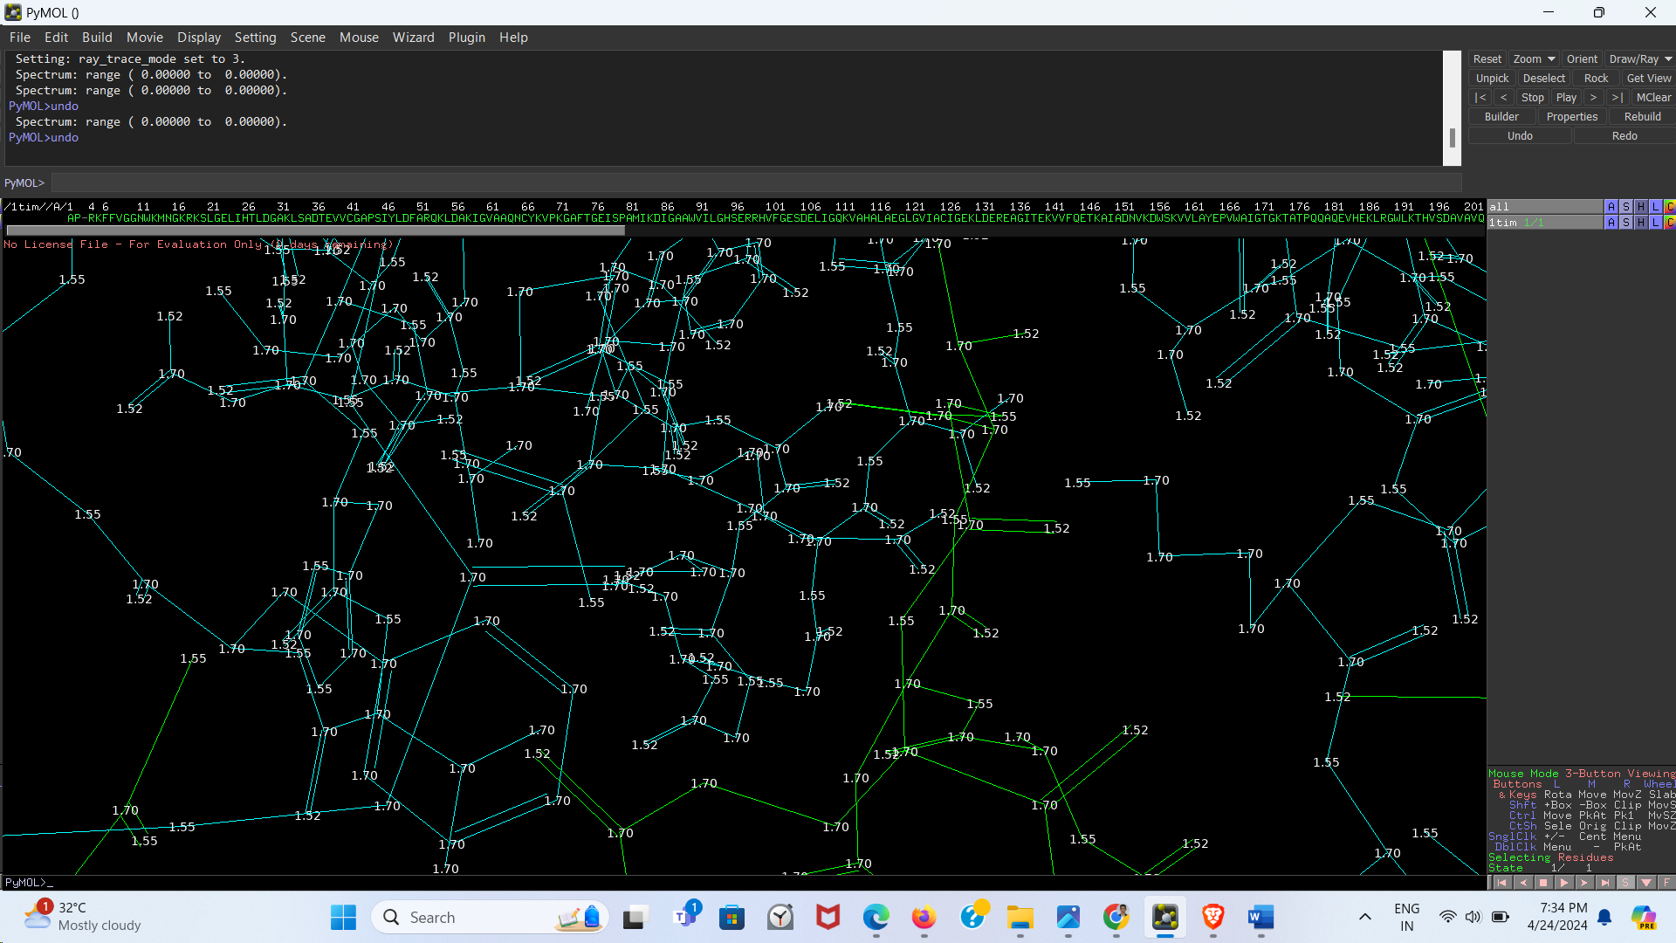

## **Q14) Compute the distance between CG and CD2 in Leu24**

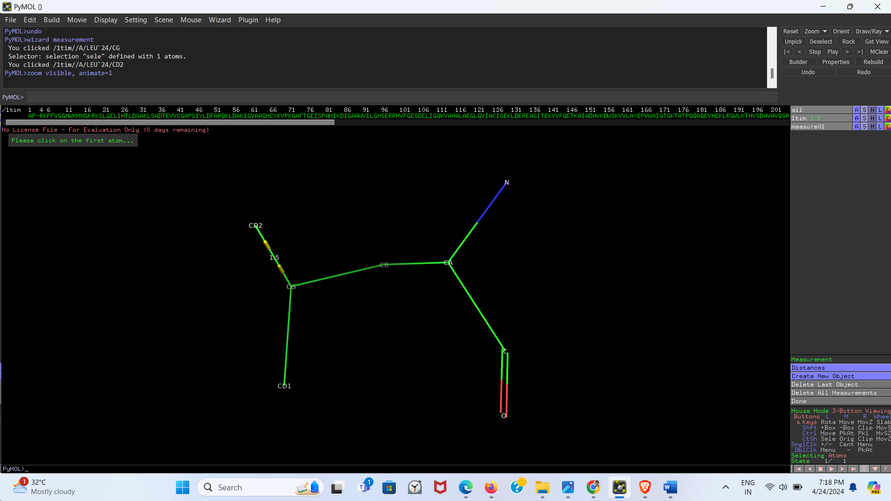

## **Q15) Compute the angle formed by the atoms CD1, CG and CD2 in Leu24.**

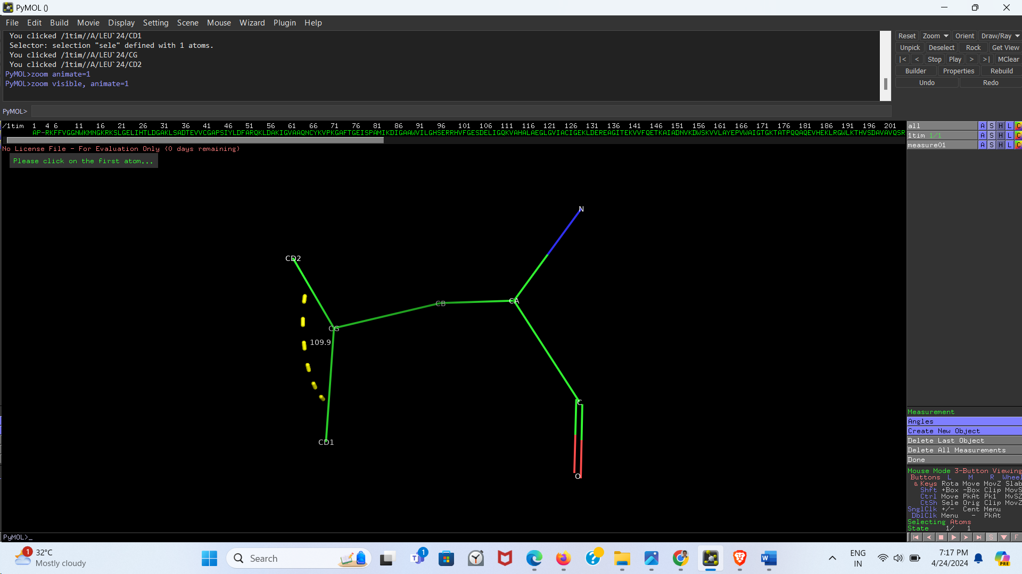

## **Q16) Compute the dihedral angles of Leu24**

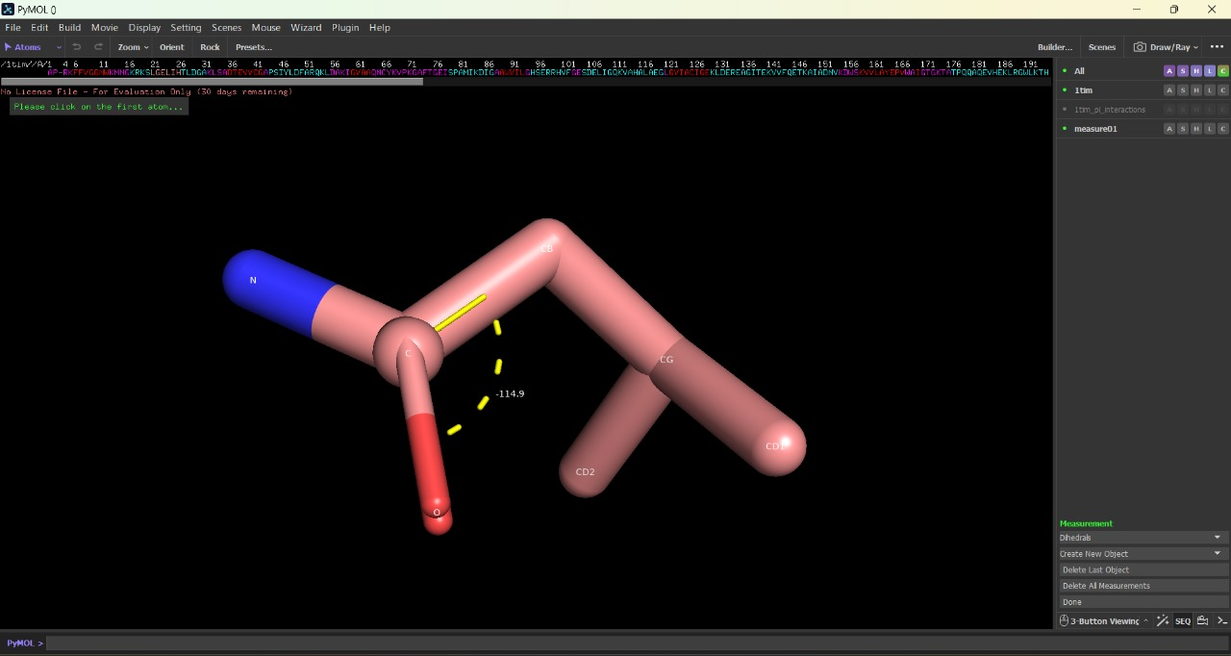

Dihedral Angle: -114.9

## **Q17) Change the background to white.**

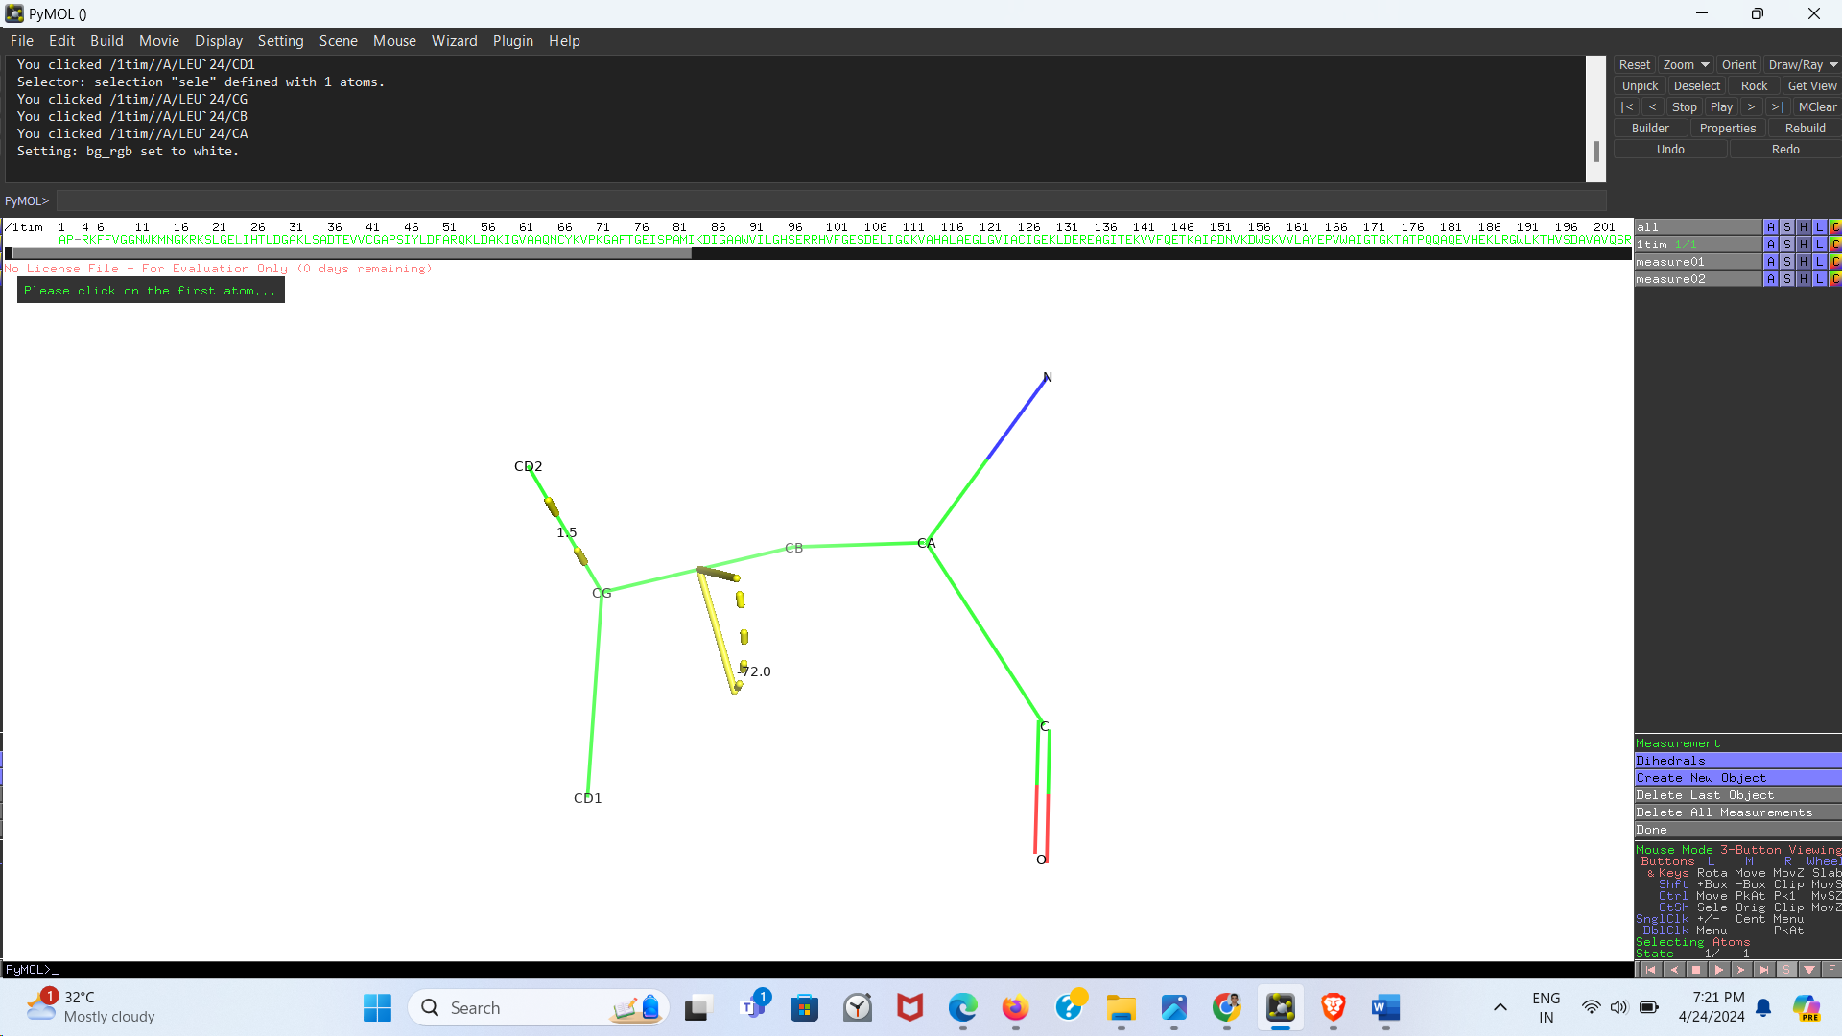

## **Q18) Make high quality picture (use ray)**

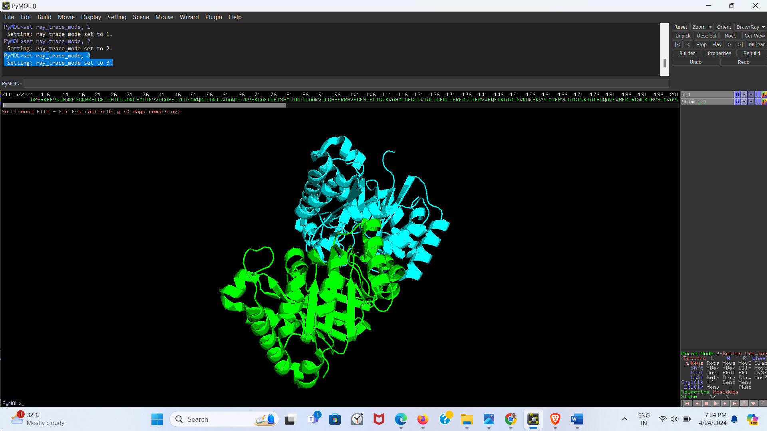

## **Q19) Show B-factors to see flexible and rigid regions (color by spectrum, b-factor)**

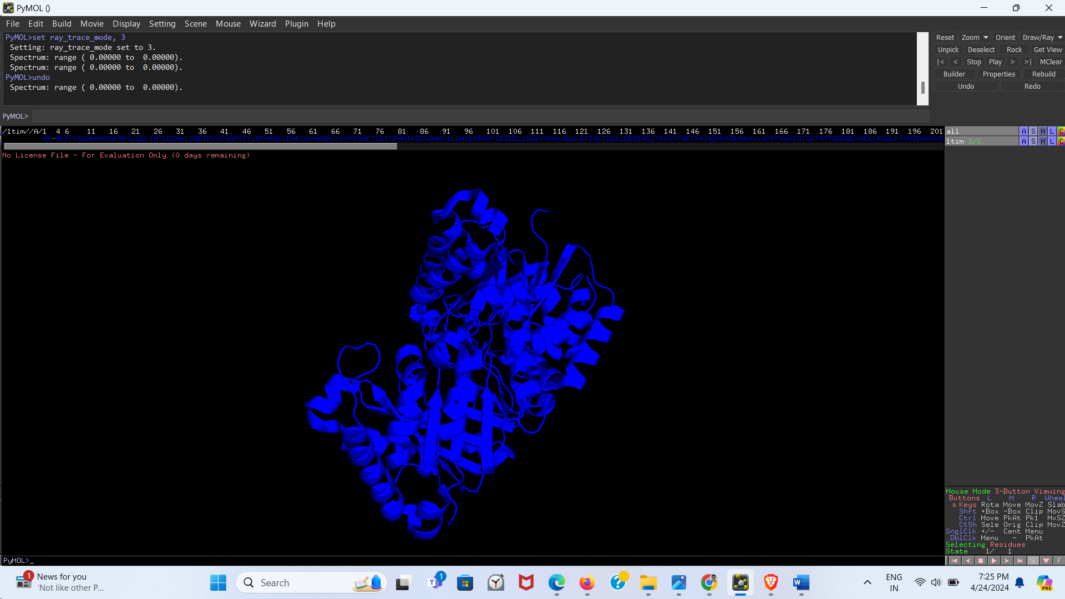

## **Q20) Compute the electrostatic potential (A -> generate -> vacuum statistics -> protein contact potential)**

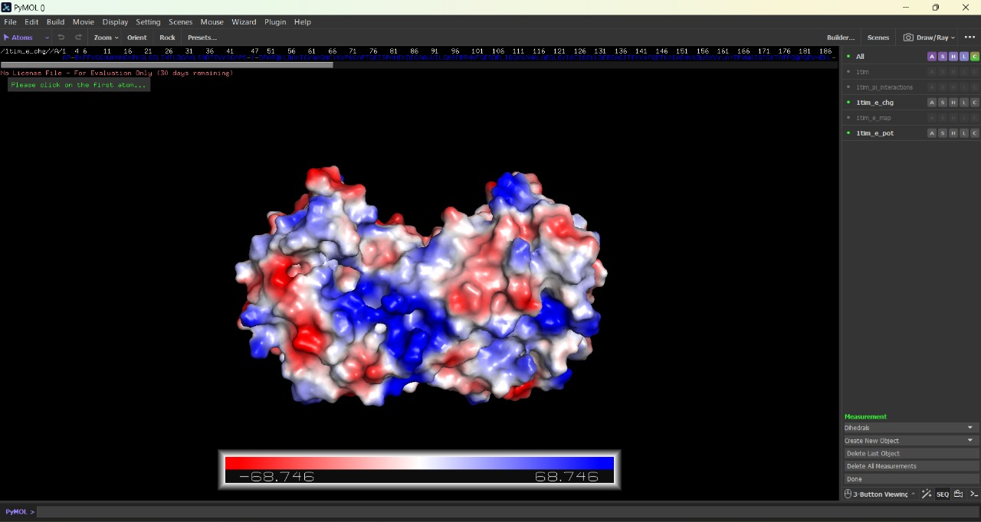

## **Q21) Save the image in PNG format**

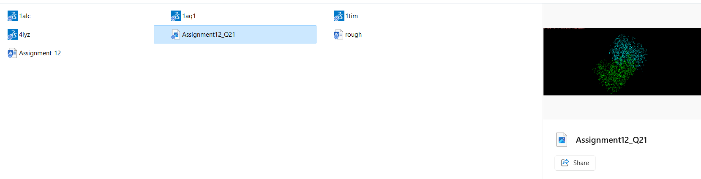

Image saved with file name ‘Assignment12_Q21.png’

## **Q22) Open the files 1ALC and 4LYZ**

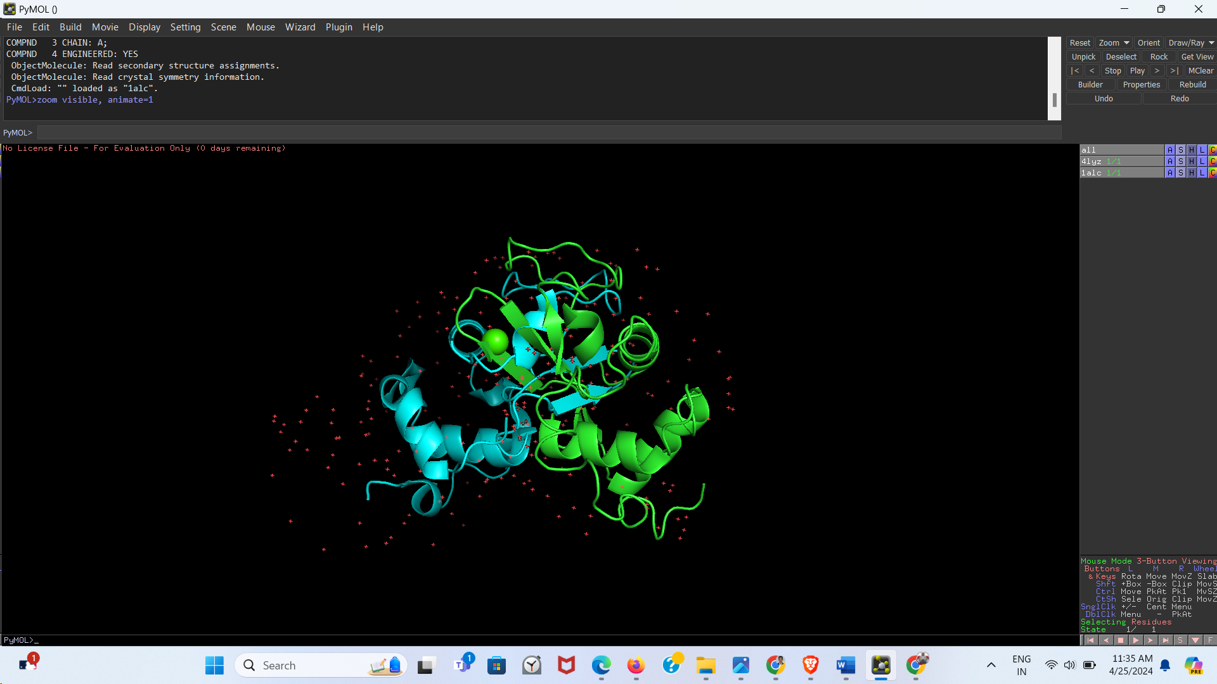

## **Q23) Align the structures**

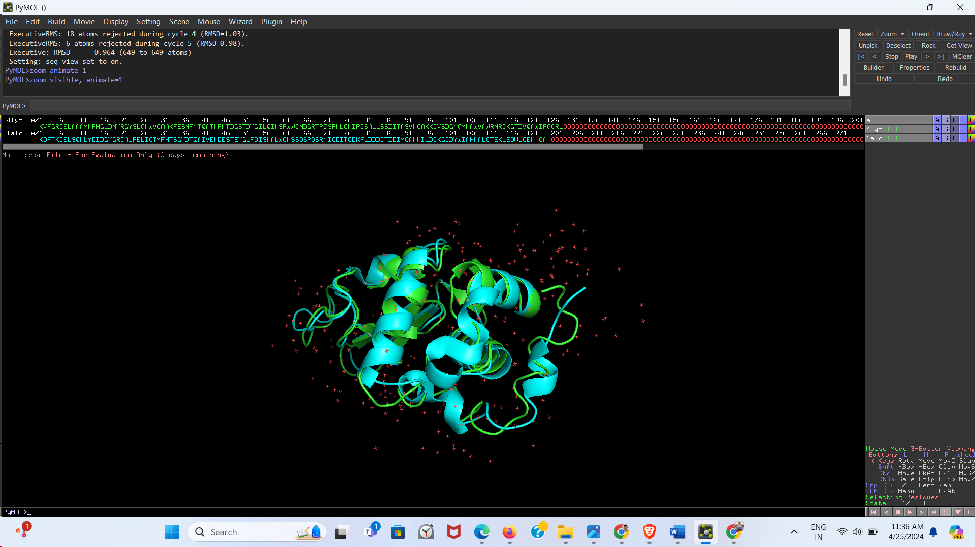

## **Q24) Compute RMSD.**

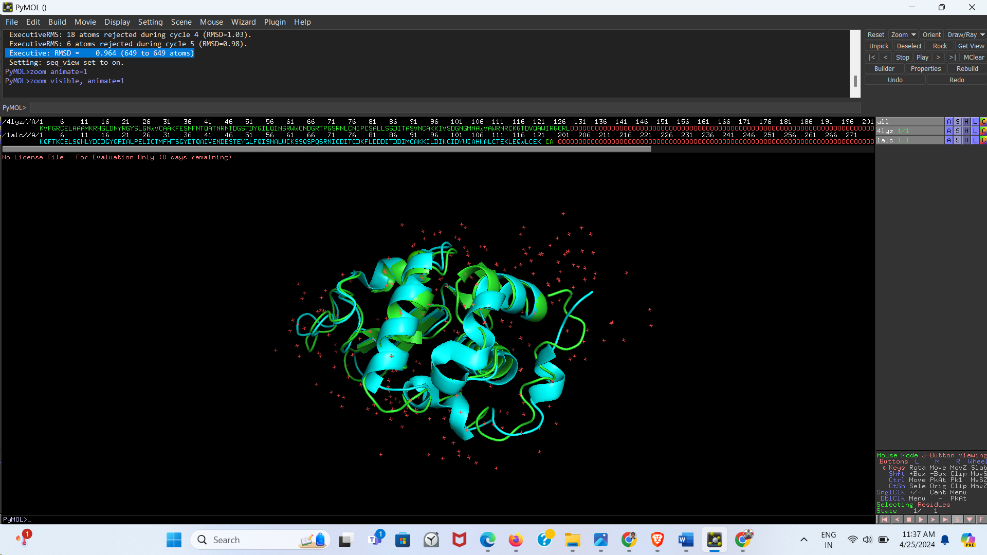

RMSD = 0.946

## **Q25) Save the aligned protein structure**

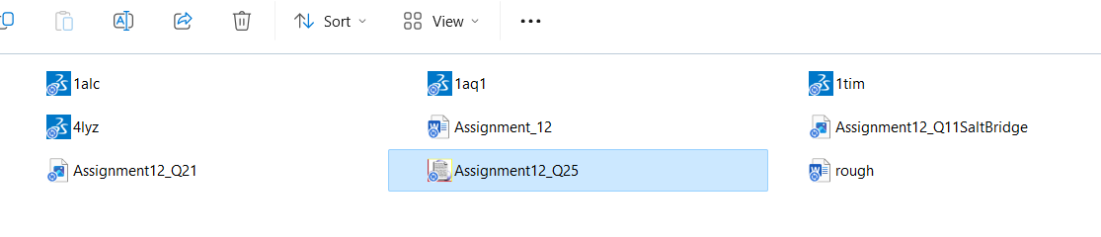

File saved as ‘Assignment12_Q25’

## **Q26) Download a protein structure with ligand(s). Identify the ligand and select residues within 3.5Å. Show any one type of interaction between them.**

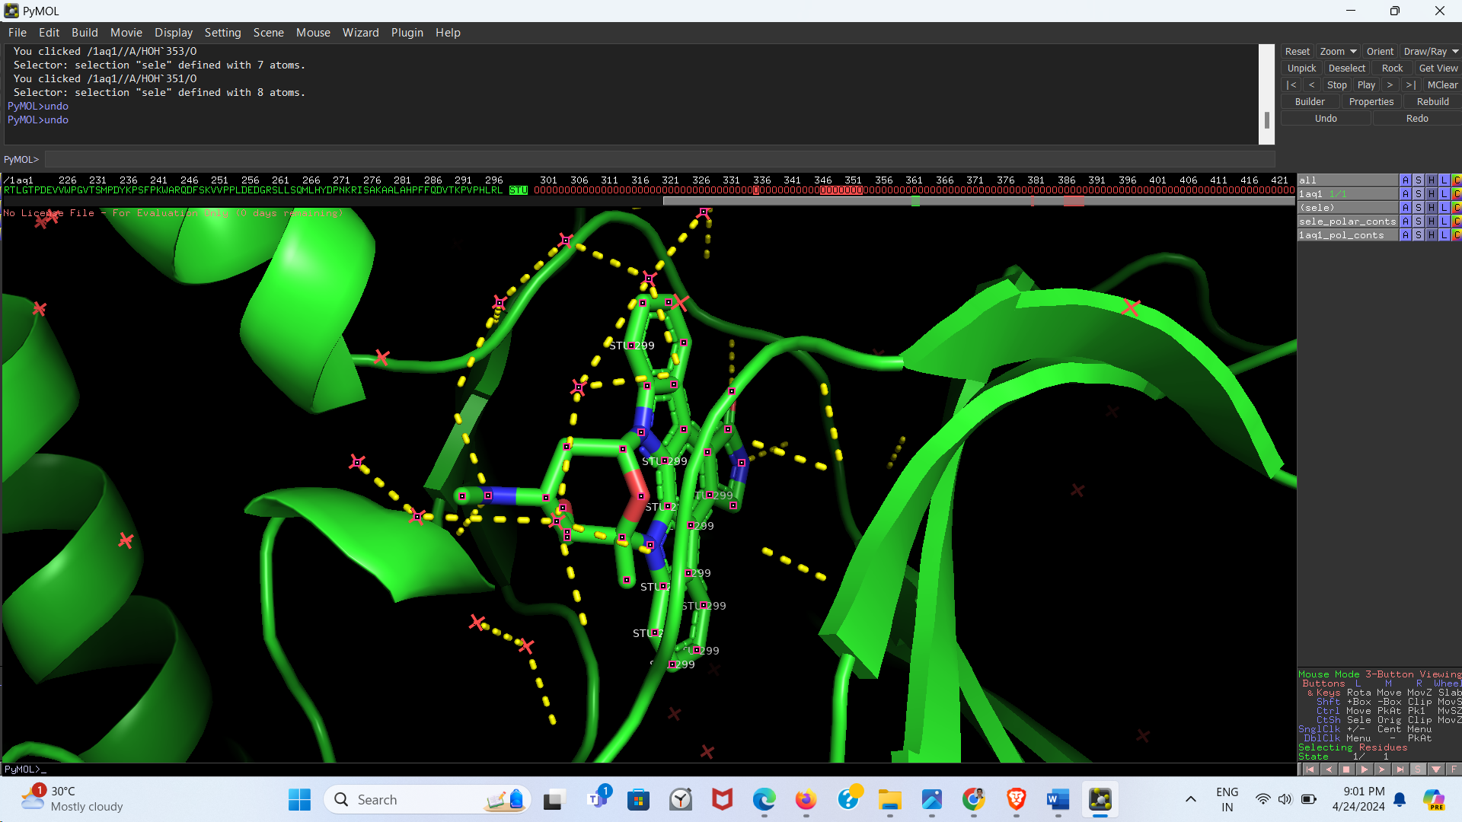

*The yellow lines represent polar interactions.*

## **Q27) Mutate any one of the active site residues and describe the change in the interaction with the ligand before and after mutation.**

*Before:*

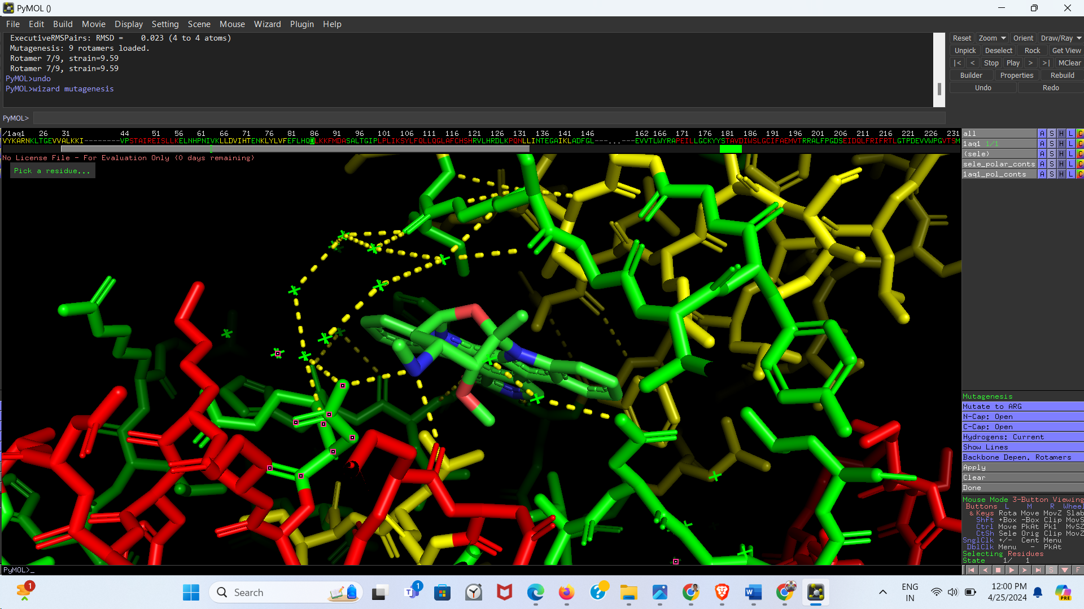

*After:*

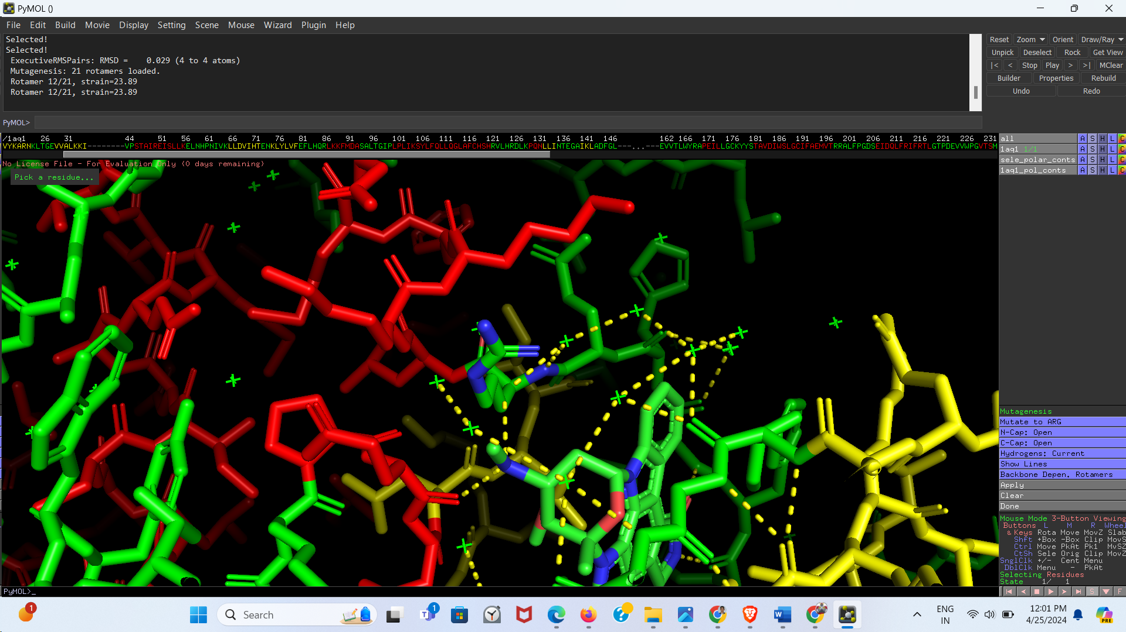

**Description:** Aspartic Acid (D) was changed to Arginine (R), thus replacing a negative charge with positive charge. The interaction of protein-ligand at that residue is lost. Earlier the interaction, was between positively charged ‘N’ of ligand and ‘O- ‘of Aspartic Acid. Now there is no interaction, in fact repulsion between positively charged ‘N’ of both the groups